**What are the various problems that could arise in Binary Encoding if a continous stream of 0s or 1s is sent?**

Binary Encoding

* Data is encoded into bits for transmission.
* Bit voltages are either 0 or 1.
* Bit stream is a continuous sequence of bits.

Problems with Binary Encoding

* A receiver cannot tell the difference between a 0 bit and no signal at all (Costa, 2008).
* There is a lack of synchronization (Degada, n.d.)

Solution A - Manchester Encoding

* Create a voltage transition at the middle of a bit.
* A 1 bit is transmitted by having the initial voltage high and transition to low.
* A 0 bit is transmitted with an initial low voltage and then high during the second phase.

Solution B - Differential Manchester Encoding

* The voltage transitions between bit intervals indicates which type of bit we have.
* The 1 bit has no voltage transition at the beginning of a bit interval.
* A 0 bit starts with a transition.

Drawback of Manchester Encoding

* Since each bit interval sends two voltages, more bandwidth is needed.

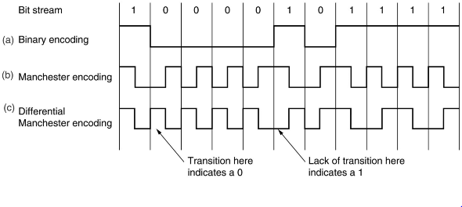(excerpted from Costa, 2008).

References

Costa, P. (2008). Computer Networks: Medium Access Control Sublayer. Retrieved from <http://research.microsoft.com/en-us/um/people/pcosta/cn_slides/cn_04.pdf>

Degada, A. (n.d.). Base-Band Digital Data Transmision. Retrieved from <https://view.officeapps.live.com/op/view.aspx?src=http%3A%2F%2Famitdegada.weebly.com%2Fuploads%2F4%2F8%2F8%2F0%2F488033%2Fbase-band_digital_data_transmission.ppt>